Welcome to the Craniofacial Family Fun Day at Rathbeggan Lakes!
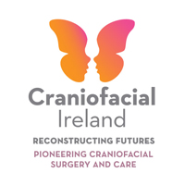
11am
Arrive at Rathbeggan Lakes – please check in with a member of the Craniofacial Team in the white tent and we will check you off our booking list and give you your special wristbands for the day.
11am – 2pm:
Join us for some face- painting & balloon making as you arrive.

Throughout the day enjoy all the fun things to do, see www.rathbegganlakes.com for details of activities available.

Enjoy the DJ & the Giant Games available on the day (Operation, Jenga & Connect 4).
Food available on the day from Sidewalk Catering!
Don’t forget your raincoats & wellies (just in case!) & sunglasses & sun-cream!

Please send any photographs you take on the day to us at craniofacialfunday@cuh.ie
We will display them on our website www.craniofacial.ie
We look forward to seeing you on Saturday!

The Craniofacial Team

