- Camera or Phone camera:

- Ask in your household who has the best camera on their phone or a normal camera, use this one as it will allow for better and sharper photographs to allow the consultant to make a more effective assessment of your child.

- Where and when to take the photographs:

- Ideally have two people to help take photographs, one to hold/distract your child and the other to take the photographs.

- Take photographs in a brightly lit room; this can be a sitting room, bedroom or bathroom. Try and take during the daytime if possible.

- Make sure that the background of the picture is a different colour to that of the child’s skin and hair. This will help us see the shape of their brow and head better for diagnostic purposes. For e.g.: use a white sheet or black towel on the bed or on the headboard to create this background.

- If your child has a lot of hair, we advise taking photos after a bath when hair is wet to allow for a better view of your child’s head shape.

- We understand that not all children can sit still for very long so maybe take some photographs in one session and then take the rest in a second session after a nap, a snack or playtime.

- Taking photographs:

- Make sure you get all of your child’s head in the photograph. Take from approximately 1ft (30cms) away.
- The consultant is looking to see the shape of all of their head, front, back and sides, as well as the appearance of their face.
- Smiling photographs are fine but try to get some neutral expressions as well, especially of their face.

- How many photos to take?

- There are 6 photographs you have to take, as outlined in the diagram and sample pictures below. Use these sample photos as your guide and checklist. You can take as many photos as you like as long as you tick those 6 boxes, send us your best 6 photos. Add photo images as a link here

- Please send your final 6 photos to our email: craniofacial@cuh.ie referencing your child’s name and date of birth.

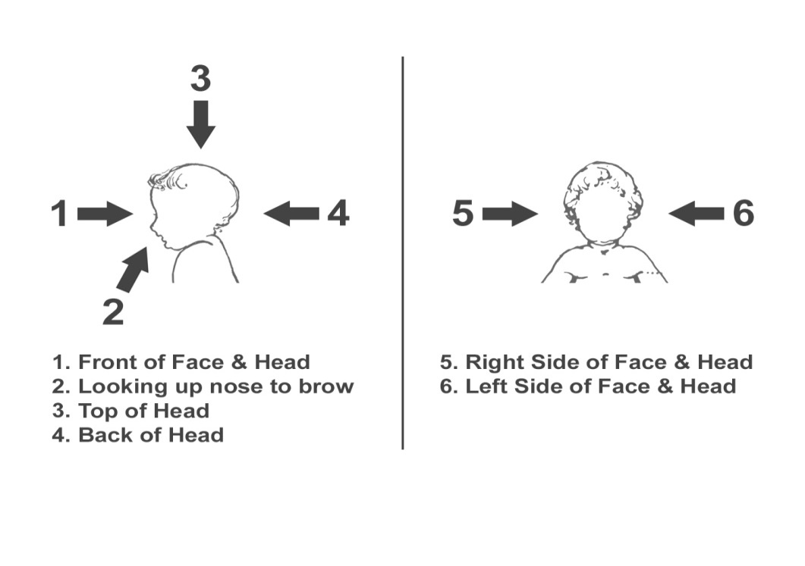

Tips from our Clinical Photographer when taking 6 different views:

- Facial view: make sure your child’s nose is in the centre of the photograph and that you have their chin, ears and the top of their head in the photograph. Try to get them to look straight at the camera so no tilting their head forwards or backwards.

- Lateral view (left and right): your child’s ear should be the centre of the photograph this time and that you are getting their nose and chin in the photo, their forehead and the back of their head as well. It might help to have a second person distracting them off to the side to get this photo. They can tilt their head up and down a bit in this one but make sure they don't tilt their head towards or away from you. If they are doing this a lot, you might need to change your position by standing up or kneeling down to get the photo.

- View up: have them lie down flat on a surface that isn't too soft. If the surface is too squishy, then they will sink into it and parts of their head won't be visible in the photos. If a second person dangles a toy above their head this might help but make sure, if they reach up towards the toy, make sure that your child’s hands don't get in the photo. This view should show the shape of their forehead at the top of the photo, try and get as much of the curve as you can.

- View down - same as before, not too soft a surface but this time from above. The curve of your child’s forehead should be at the bottom of the photo with a little bit of their chin visible at the top of the photo.

- Top down - same again with a not too soft a surface as this view has to show the shape of your child’s head from the brow at the top of the photo to the back of their head at the bottom of the photo. You'll probably be able to see a bit of their ears sticking out either side as well. You shouldn't see much of their face in this photo, the forehead should obscure it, this is fine, and it’s the shape of the head we want to capture in this photo.

